

**PC-CENTRE**

**E-Project Documentation**

**Teacher Name: Miss Mahnoor Tahir**

**APTECH COMPUTER EDUCATION**

**HYDERABAD-1 PAKISTAN**

**Issue Date: 8-Nov-24**

TABLE OF CONTENT

|  |  |  |
| --- | --- | --- |
| **S No** | **Contents** | **Page No** |
| 01 | Certificate | 3 |
| 02 | Acknowledgement | 4 |
| 03 | Project Report | 5 |
| 04 | Problem Definition | 6 |
| 05 | Customer Requirements Specification  (CRS) | 7 |
| 06 | Architecture Design of the Project | 8 |
| 07 | System Requirement | 9 |
| 08 | Task Sheet | 10 |
| 09 | Project Plan | 11 |
| 10 | Checklist of work Progress | 12 |
| 11 | Final Check List | 13 |
| 12 | Screen Shots | 14 |
| 13 | Source Code | 16 |

CERTIFICATE

This is to certify that

**MUHAMMAD SUFIYAN, ABDULLAH, HAFSA AND AFFAN AHMED**

Submitted by:

**ALL GROUP MEMBERS**

Has successfully Designed

PC-CENTRE

Date of Issue: **8-Nov-24**

Authorized Signature: Miss Mahnoor Tahir

ACKNOWLEDGEMENT

First and foremost, we would like to express our deep gratitude and most heartfelt thanks to almighty ALLAH for his blessings, for lightening up our heart with the torch of knowledge and for giving us the ability to complete this project.

We would like to thanks Aptech Worldwide and the team of E-Project for their generous support and clarifying the doubts regarding e-project. We would like to acknowledge the way of explanation which the team of e-project gave in e-project to make website and we are equally grateful to our teacher (Miss Mahnoor) for giving us a moral support and guiding us different matters regarding project in all the time about the research and writing of this project.

We are greatly indebted to Aptech Worldwide, Miss Mahnoor, Faculty Members and ACE Hyderabad, Pakistan for encouragement and incessant help.

PROJECT REPORT

**BY:**

**Student1593917 MUHAMMAD SUFIYAN .**

**Student1593930 ABDULLAH .**

**Student1593649 HAFSA .**

**Student1593914 AFFAN AHMED .**

Project Title: ASTRONOMY

Members Name: Muhammad Sufiyan, Abdullah , Hafsa and Affan Ahmed

Batch Code: 2407E

Start Date: 8-nov -2024

End Date: 26-nov -2024

Course: ACCP-PRIME (CPISM)

Teacher: Miss Mahnoor Tahir

Center Manager: Sir Shoaib Ahmed

Center Academic Head: Sir Zubair

Center Name: ACE Hyderabad-1, Pakistan

Submitted as

E Project Documentation

**PROBLEM STATEMENT**

People have a deep interest in understanding the universe, but often lack access to accessible, visually appealing, and well-organized information about astronomy. While there is an abundance of scientific data on space, planets, stars, and celestial phenomena, much of it is presented in highly technical language that can be difficult for the general public to comprehend. Additionally, many websites on astronomy lack user-friendly design and interactive elements, which can make the learning experience less engaging.

To create an astronomy-focused website that makes complex astronomical concepts understandable, visually engaging, and organized in a way that encourages exploration and learning. The website should serve as an accessible resource for both beginners and enthusiasts by combining well-structured information with high-quality visuals, navigation ease, and interactive features.

1. **Accessible Information**: Provide clear, simplified explanations of astronomy topics (e.g., planets, stars, galaxies, black holes) to make them understandable for people with varying levels of knowledge.
2. **Engaging Visuals**: Use high-quality images and an astronomy-themed design that adds to the user experience, making space feel close, exciting, and awe-inspiring.
3. **Easy Navigation**: Organize content with intuitive navigation and categorized links to allow users to easily explore topics of interest.
4. **Interactive Elements**: Integrate features like image galleries, social media links, and "Learn More" sections to encourage user interaction and ongoing engagement with the site’s content.

By addressing these goals, the website can become a valuable educational tool that sparks curiosity, provides accurate information, and enables a user-friendly experience for anyone interested in learning more about the universe.

Architecture & Design of the Project:

Since the website will have client architecture it will have one-tier architecture.

System Requirement:

|  |  |  |
| --- | --- | --- |
| **SR.No** | **Items** | **Description** |
| 01 | Operating System | Window XP, Win7 or win8 |
| 02 | Main Processor | Minimum 2ghz or better |
| 03 | Ram (Memory) | Minimum 512mb or better |
| 04 | Web Browser | Google Chrome or Firefox (Latest) |
| 05 | Software | Notepad, HTML editor, Adobe Dreamweaver CS5.5 |

TASK SHEET

|  |  |  |  |  |  |
| --- | --- | --- | --- | --- | --- |
| **Project Ref. No:** | | **Date of Preparation of Activity Plan:** | | | |
| Sr.no | Task | Actual  Start Date: | Actual  Day: | Team  Mates Names: | Status: |
| 01 | Meeting | 8 nov, 2024 | 1 | Sufiyan,Hafsa, Abdullah,Affan |  |
| 02 | Data  Collection | 12 nov, 2024 | 1 | Sufiyan,Hafsa, Abdullah,Affan |  |
| 03 | Designing  Home  Page | 14 nov, 2024 | 5 | Sufiyan,Hafsa, Abdullah,Affan |  |
| 04 | Linking | 16 nov, 2024 | 1 | Sufiyan,Hafsa, Abdullah,Affan |  |
| 05 | Check  Links | 17 nov, 2024 | 1 | Sufiyan,Hafsa,Abdullah,Affan |  |
| 06 | Designing Menu Page | 19 nov, 2024 | 4 | Sufiyan,Hafsa, Abdullah,Affan |  |
| 07 | Designing Other Pages | 21 nov, 2024 | 6 | Sufiyan,Hafsa, Abdullah,Affan |  |
| 06 | Finalizing | 23 nov, 2024 | 1 | Sufiyan,Hafsa, Abdullah,Affan |  |
| 08 | Documentation | 24 nov, 2024 | 1 | Sufiyan,Hafsa, Abdullah,Affan |  |
| 09 | Uploading | 26 nov, 2024 | 2 | Sufiyan,Hafsa, Abdullah,Affan |  |

PROJECT PLAN

* Website is able to execute quickly.
* The color combination of our website is so attractive.
* The collection of data is authentic and taken by the most popular product websites.
* Background of each page is as same as the main page.
* The contact page is well prepared exactly for the same page as user clicks on the link...
* A user can resolve its difficulties easily from this site.

CHECK LIST OF WORK PROGRESS

|  |  |  |
| --- | --- | --- |
| **SR. No** | **Aspect Tested** | **Remarks** |
| 01 | Data Collection |  |
| 02 | Designing Home Page |  |
| 03 | Linking The Pages |  |
| 04 | Designing Other Pages |  |
| 05 | Finalization |  |
| 06 | Documentation |  |

FINAL CHECK LIST

|  |  |  |  |
| --- | --- | --- | --- |
| **SR.No** | **Particulars** | **Yes** | **No** |
| 01 | Do all pages open? | YES |  |
| 02 | Are all hyperlinks working? | YES |  |
| 03 | Are the web page contents devoid for  spelling mistakes? |  | No |
| 04 | Are all the web components working? | YES |  |
| 05 | Is site browser compatible? | YES |  |

SCREEN SHOTS:

HOME PAGE

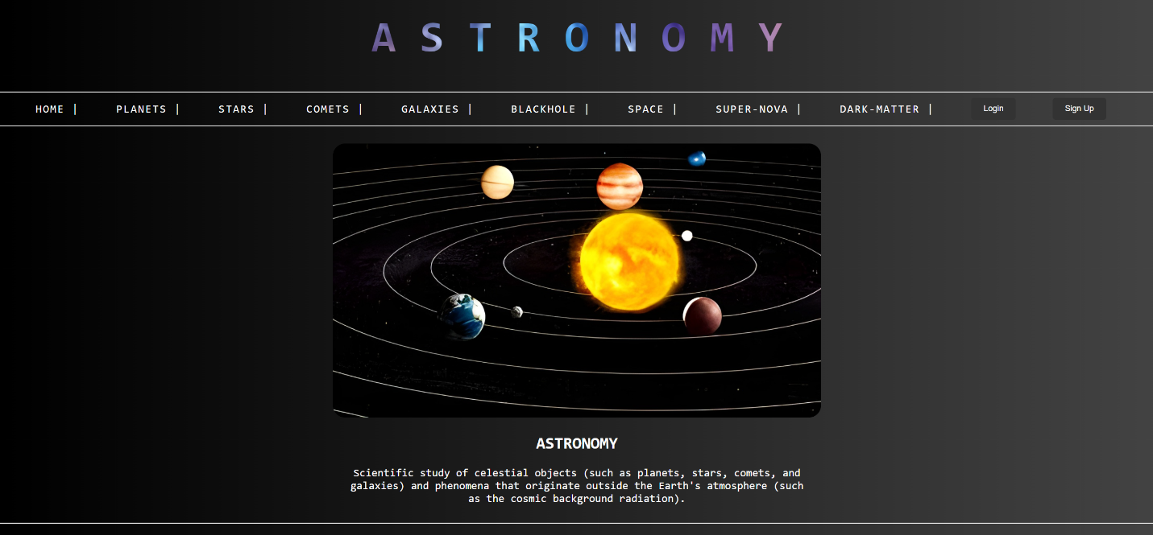

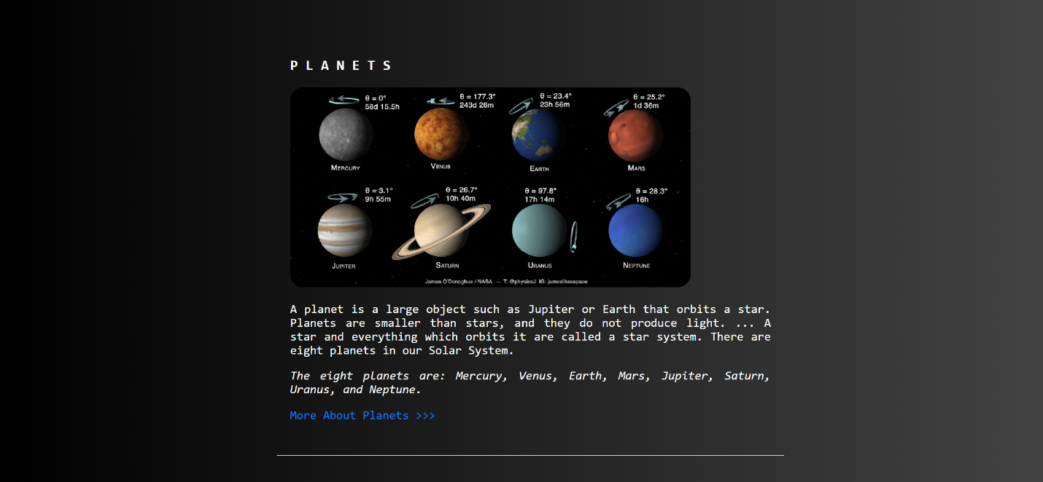

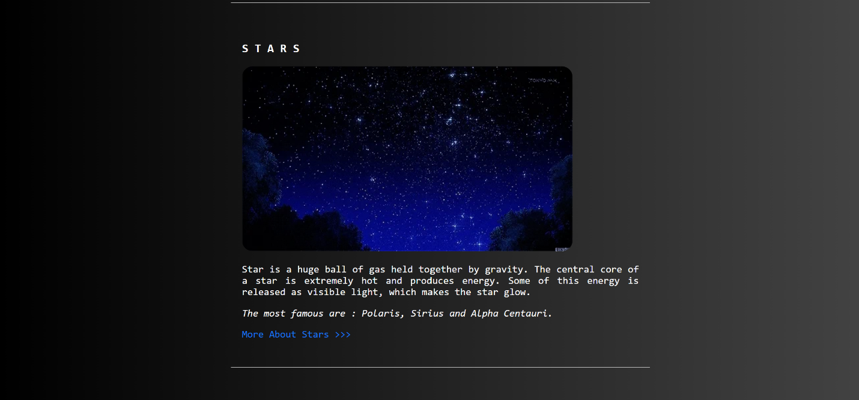

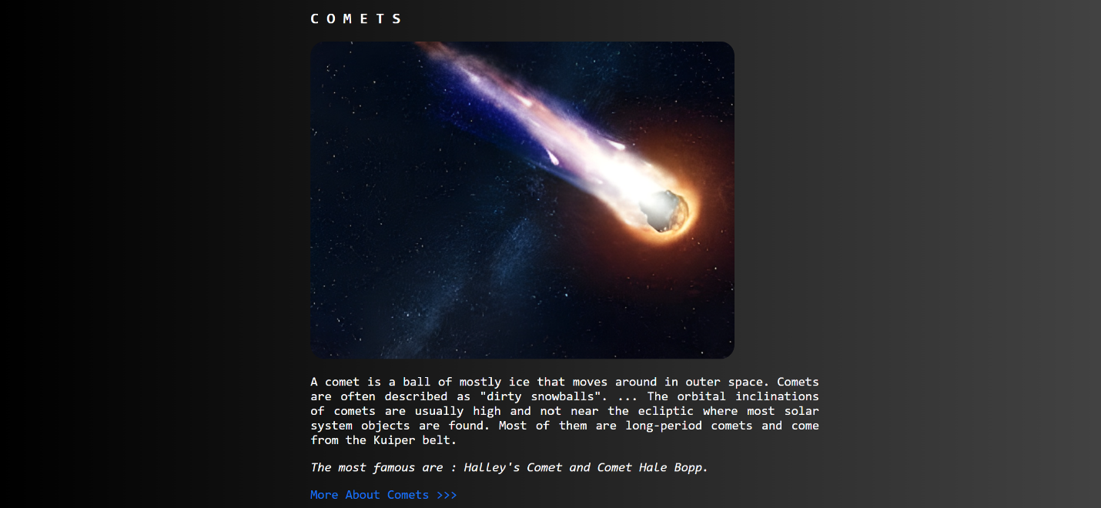

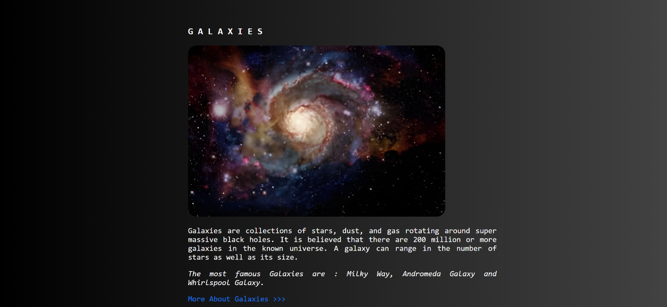

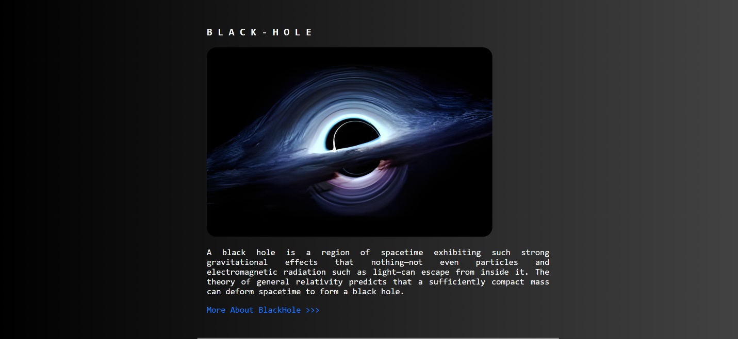

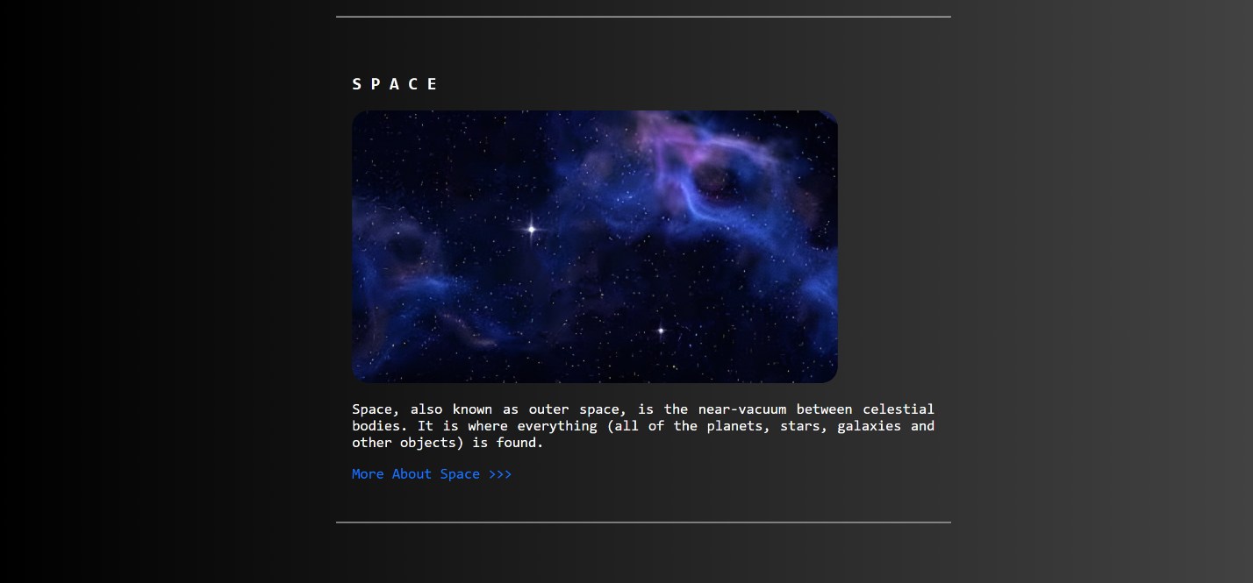

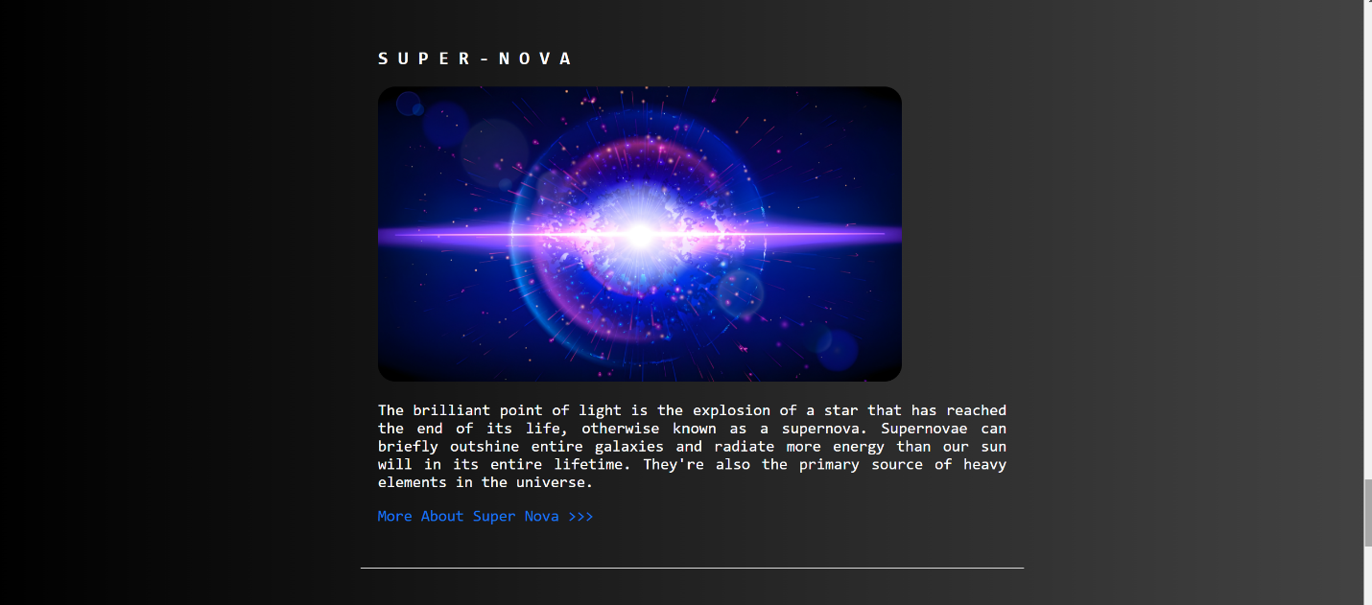

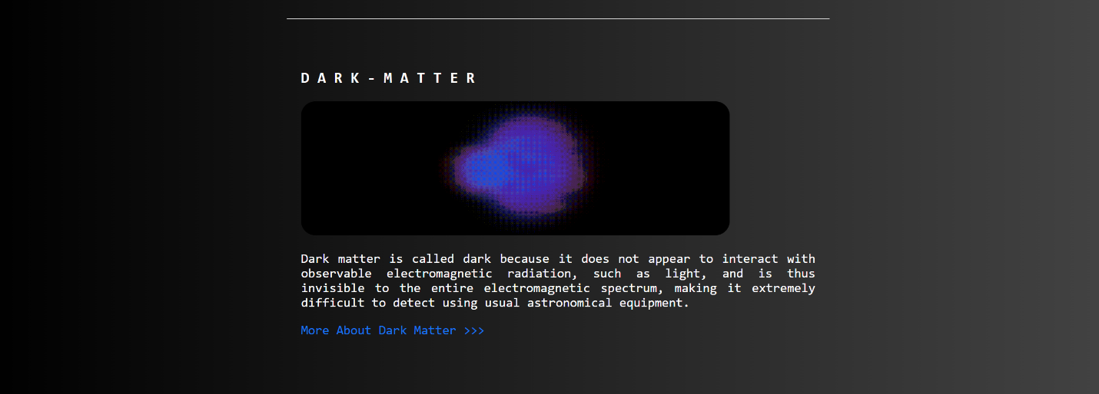

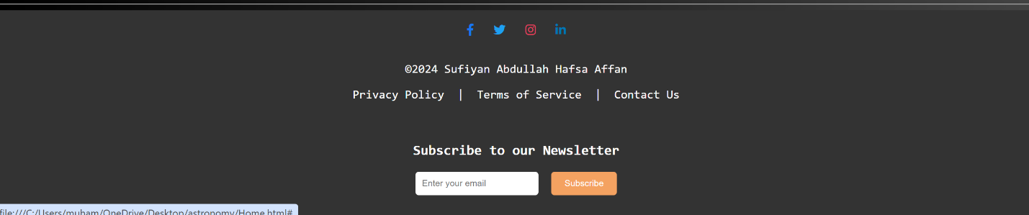

SOURCE CODE:

<!DOCTYPE html>

<html lang="en">

<head>

<meta charset="UTF-8">

<meta name="viewport" content="width=device-width, initial-scale=1.0">

<meta http-equiv="X-UA-Compatible" content="ie=edge">

<title>Astronomy</title>

<!-- Stylesheets -->

<link rel="stylesheet" href="assets/css/style.css">

<link href="https://cdnjs.cloudflare.com/ajax/libs/font-awesome/6.0.0-beta3/css/all.min.css" rel="stylesheet">

</head>

<body>

<!-- Header -->

<header>

<h1 style="background-image: url('h2.jpeg'); text-align: center;">A S T R O N O M Y</h1>

</header>

<hr>

<!-- Navigation -->

<nav>

<ul>

<li><a href="#">HOME |</a></li>

<li><a href="#p">PLANETS |</a></li>

<li><a href="#s">STARS |</a></li>

<li><a href="#c">COMETS |</a></li>

<li><a href="#g">GALAXIES |</a></li>

<li><a href="#b">BLACKHOLE |</a></li>

<li><a href="#sp">SPACE |</a></li>

<li><a href="#sn">SUPER-NOVA |</a></li>

<li><a href="#d">DARK-MATTER |</a></li>

<li><button>Login</button></li>

<li><button>Sign Up</button></li>

</ul>

</nav>

<hr>

<!-- Main Content -->

<main>

<section id="astronomy">

<img class="img" src="./assets/pictures/images (1).jpeg" alt="Astronomy Image" width="800">

<h2><strong>ASTRONOMY</strong></h2>

<p>Scientific study of celestial objects (such as planets, stars, comets, and galaxies) and phenomena that originate outside the Earth's atmosphere (such as the cosmic background radiation).</p>

</section>

<hr>

<!-- Pages -->

<section id="pages">

<ul>

<!-- Planets -->

<li>

<h3 id="p">P L A N E T S</h3>

<img src="./assets/pictures/img1.gif" alt="Planets Image" width="600">

<p>A planet is a large object such as Jupiter or Earth that orbits a star. Planets are smaller than stars, and they do not produce light. ... A star and everything which orbits it are called a star system. There are eight planets in our Solar System.<br></p>

<em><p>The eight planets are: Mercury, Venus, Earth, Mars, Jupiter, Saturn, Uranus, and Neptune.</p></em>

<a href="#">More About Planets >>></a>

</li>

<hr>

<!-- Stars -->

<li>

<h3 id="s">S T A R S</h3>

<img src="./assets/pictures/img2.webp" alt="Stars Image" width="600">

<p>A star is a huge ball of gas held together by gravity. The central core of a star is extremely hot and produces energy. Some of this energy is released as visible light, which makes the star glow.<br></p>

<em><p>The most famous are: Polaris, Sirius, and Alpha Centauri.</p></em>

<a href="#">More About Stars >>></a>

</li>

<hr>

<!-- Comets -->

<li>

<h3 id="c">C O M E T S</h3>

<img src="./assets/pictures/img3.jpeg" alt="Comets Image" width="600">

<p>A comet is a ball of mostly ice that moves around in outer space. Comets are often described as "dirty snowballs". Most of them are long-period comets and come from the Kuiper belt.<br></p>

<em><p>The most famous are: Halley's Comet and Comet Hale Bopp.</p></em>

<a href="#">More About Comets >>></a>

</li>

<hr>

<!-- Galaxies -->

<li>

<h3 id="g">G A L A X I E S</h3>

<img src="./assets/pictures/img4.jpeg" alt="Galaxies Image" width="600">

<p>Galaxies are collections of stars, dust, and gas rotating around supermassive black holes. It is believed that there are 200 million or more galaxies in the known universe.<br></p>

<em><p>The most famous Galaxies are: Milky Way, Andromeda Galaxy, and Whirlpool Galaxy.</p></em>

<a href="#">More About Galaxies >>></a>

</li>

<hr>

<!-- Black Hole -->

<li>

<h3 id="b">B L A C K - H O L E</h3>

<img src="./assets/pictures/img5.jpeg" alt="Black Hole Image" width="600">

<p>A black hole is a region of spacetime exhibiting such strong gravitational effects that nothing—not even particles and electromagnetic radiation such as light—can escape from inside it.</p>

<a href="#">More About BlackHole >>></a>

</li>

<hr>

<!-- Space -->

<li>

<h3 id="sp">S P A C E</h3>

<img src="./assets/pictures/img6.jpeg" alt="Space Image" width="600">

<p>Space, also known as outer space, is the near-vacuum between celestial bodies. It is where everything (all of the planets, stars, galaxies, and other objects) is found.</p>

<a href="#">More About Space >>></a>

</li>

<hr>

<!-- Super Nova -->

<li>

<h3 id="sn">S U P E R - N O V A</h3>

<img src="./assets/pictures/img7.jpg" alt="Supernova Image" width="600">

<p>A supernova is the explosion of a star that has reached the end of its life. They can briefly outshine entire galaxies and radiate more energy than our sun will in its entire lifetime.</p>

<a href="#">More About Supernova >>></a>

</li>

<hr>

<!-- Dark Matter -->

<li>

<h3 id="d">D A R K - M A T T E R</h3>

<img src="./assets/pictures/img8" alt="Dark Matter Image" width="600">

<p>Dark matter is invisible to the electromagnetic spectrum, making it extremely difficult to detect using usual astronomical equipment.</p>

<a href="#">More About Dark Matter >>></a>

</li>

</ul>

</section>

</main>

<hr>

<!-- Footer -->

<footer>

<div class="footer-content">

<!-- Social Links -->

<div class="social-links">

<a href="https://facebook.com" target="_blank" class="facebook">

<i class="fab fa-facebook-f"></i>

</a>

<a href="https://twitter.com" target="_blank" class="twitter">

<i class="fab fa-twitter"></i>

</a>

<a href="https://instagram.com" target="_blank" class="instagram">

<i class="fab fa-instagram"></i>

</a>

<a href="https://linkedin.com" target="_blank" class="linkedin">

<i class="fab fa-linkedin-in"></i>

</a>

</div>

<!-- Footer Info -->

<div class="footer-info">

<p>©2024 Sufiyan Abdullah Hafsa Affan</p>

<a href="#">Privacy Policy</a> |

<a href="#">Terms of Service</a> |

<a href="#">Contact Us</a>

</div>

<!-- Newsletter -->

<div class="newsletter">

<h3>Subscribe to our Newsletter</h3>

<form action="#">

<input type="email" placeholder="Enter your email" required>

<button type="submit">Subscribe</button>

</form>

</div>

</div>

</footer>

</body>

</html>